**SCIENCE DEPARTMENT**

**YEAR 11**

**HUMAN BIOLOGY EXAMINATION**

**SEMESTER TWO 2008**

**Time allowed for this paper**

**Reading time before commencing work: Ten minutes**

**Working time for paper: Three hours**

**section 1: Multiple Choice – 40 Questions – 40 Marks – 40%**Answer the multiple choice questions by crossing out the letter of your choice on the answer sheet provided.***Use a 2B pencil here.***

**SECTION 2: Short Answers – 8 Questions – 97 marks – 40%**Answer the questions in the spaces provided. Answers are to be in BLUE or BLACK ink.  
***GRAPHS and DRAWINGS to be in pencil and labelled in ink.***

**SECTION 3: Extended Answer – 2 Questions – 40 marks – 20%**Answer question 1 **OR** question 2  
**AND**  
Answer question 3 **OR** question 4.

**SECTION 1: MULTIPLE CHOICE 40 MARKS**

**Mark your answers to questions 1-40 on the separate multiple choice answer sheet, using a 2B pencil. If you make an error, rub out the incorrect choice and put a cross over the correct answer. Also place the new letter choice next to the question number so there is no confusion.**

1. Carbon dioxide travels:

1. as gas bubbles in the plasma.
2. partly in the red blood cells and partly dissolved in the plasma as bicarbonate ions [HCO3 - ].
3. in the white blood cells.
4. entirely in the red blood cells.

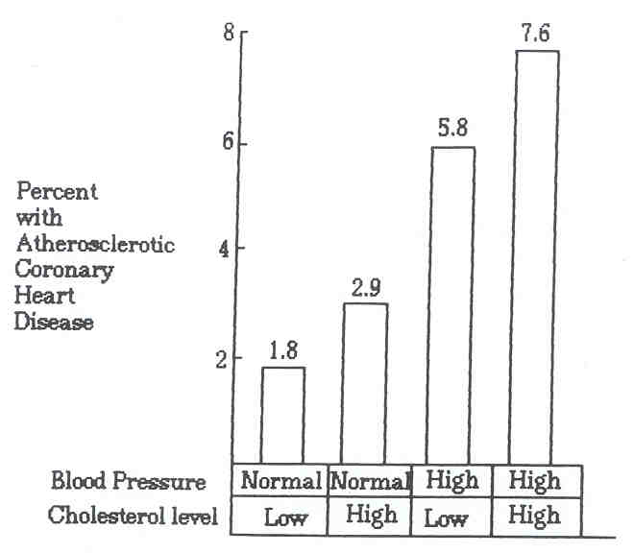

2. The graph above shows:

(a) the most important factor contributing to atherosclerosis is the amount of cholesterol in the blood.

(b) high blood pressure and low cholesterol contributes more to atherosclerosis than high cholesterol.

(c) atherosclerosis is more likely with high blood pressure and high cholesterol.

(d) high blood pressure is the only factor which is implicated in atherosclerosis.

3. When air is inhaled it flows through an air tube system to reach the air sacs. The system consists of the following:

(i) larynx (iv) bronchi

(ii) bronchioles (v) trachea

(iii) pharynx (vi) nasal cavity

What order does it follow?

|  |  |  |  |
| --- | --- | --- | --- |
| **A** | **B** | **C** | **D** |
| nasal cavity  trachea  bronchi  pharynx  bronchioles  larynx | nasal cavity  bronchi  larynx  trachea  pharynx  bronchioles | nasal cavity  pharynx  larynx  trachea  bronchi  bronchioles | nasal cavity  bronchi  bronchioles  trachea  pharynx  larynx |

(a) A.

(b) B.

(c) C.

(d) D.

4. During the process of expiration the:

(a) diaphragm lowers.

(b) ribs move upward and outward.

(c) size of the thoracic cavity increases.

(d) pressure inside the thoracic cavity increases.

5. Which of the following is true of gaseous exchange through the wall of the alveolus?

(a) Nett diffusion of oxygen is from alveoli to the blood capillaries.

(b) Nett diffusion of carbon dioxide is from alveoli to the blood capillaries.

(c) Diffusion of oxygen occurs at the same rate in both directions.

(d) Diffusion of carbon dioxide occurs at the same rate in both directions.

6. Supplemental (expiratory reserve volume) air is that which:

(a) we can inhale by making an extra effort.

(b) we can forcibly exhale after normal exhalation.

(c) remains in the lungs after all other air has been forced out.

(d) is given to deep sea divers as an emergency supply.

7. The following table shows the composition of inhaled and exhaled air.

|  |  |  |
| --- | --- | --- |
|  | **Inhaled Air** | **Exhaled Air** |
| Oxygen | 20.7% | 14.8% |
| Carbon dioxide | 0.04% | 4.3% |
| Nitrogen | 79.0% | 79.5% |
| Water vapour | Same as atmosphere | Higher than atmosphere |
| Temperature | Same as atmosphere | Higher than atmosphere |

Which of the following statements are TRUE?

A Exhaled air has a lower concentration of oxygen but a higher concentration of carbon dioxide and water vapour.

B The carbon dioxide content in exhaled air is increased 100 times due to excretion as waste through the alveoli.

C The water vapour in exhaled air is derived from the evaporation along the respiratory tract.

D The temperature of the exhaled air is higher because the air is warmed by the surrounding air near the nostrils.

(a) A and C only.

(b) A, B, C, D.

(c) B and D only.

(d) A, B and C.

8. When air is inhaled it flows through the air tube system to reach the air sacs. Which labelled part of the system contains the vocal cords?

Air tube system

Larynx Bronchioles Pharynx Bronchi Trachea Nasal cavity

**A B C D E F**

(a) A.

(b) B.

(c) C.

(d) D.

9. Many children in Australia suffer from asthma. Wheezing in asthma would be directly produced by:

(a) constriction of the bronchi and bronchioles.

(b) grass pollens in the air.

(c) mucus obstructing the nasal passages.

(d) atmospheric pollution.

10. Which of the following methods of “contraception” operates largely by preventing implantation rather than by preventing fertilization?

(a) Diaphragm.

(b) Intra-uterine device.

(c) The “pill”.

(d) Condom.

11. The structures in the following diagram labelled E and F are the

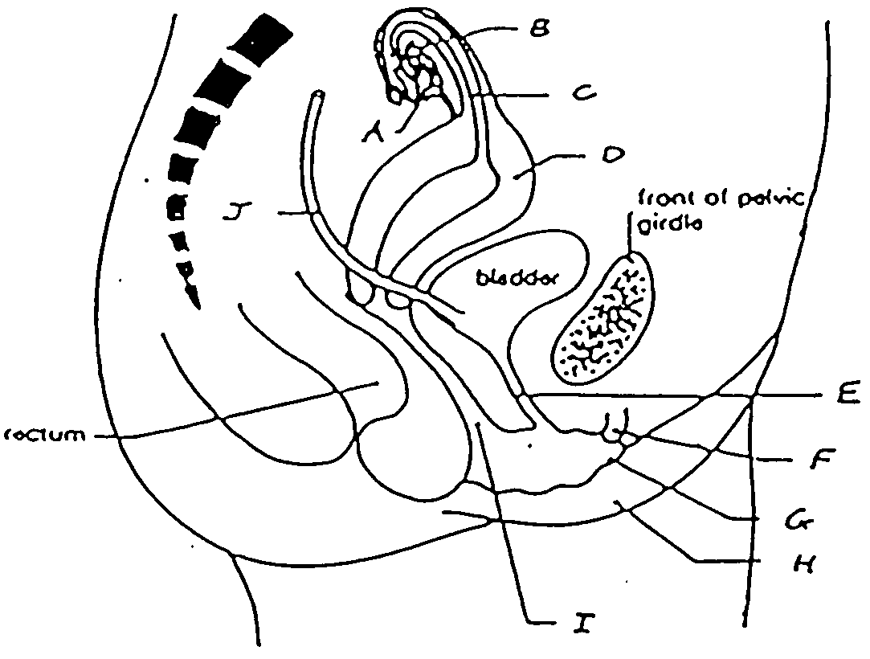

(a) urethra and bladder.

(b) fallopian tube and clitoris.

(c) labia and urethra.

(d) urethra and clitoris.

12. During the time that a foetus is developing inside the uterus

(a) it uses food that has been stored in the placenta.

(b) it is nourished via the umbilical cord.

(c) it uses food stored in a yolk.

(d) it is supplied with nutrients from the amniotic fluid.

13. The foramen ovale is found

(a) in the inferior vena cave.

(b) in between the right and left atrium.

(c) in the aorta.

(d) in between the left ventricle and the left atrium.

14. The hormone responsible for the ‘let down’ reflex is

(a) oxytocin.

(b) progesterone.

(c) prolactin.

(d) oestrogen.

15. Using the table below, the average height gained by a female between the ages of 1 year and 2 years of age is

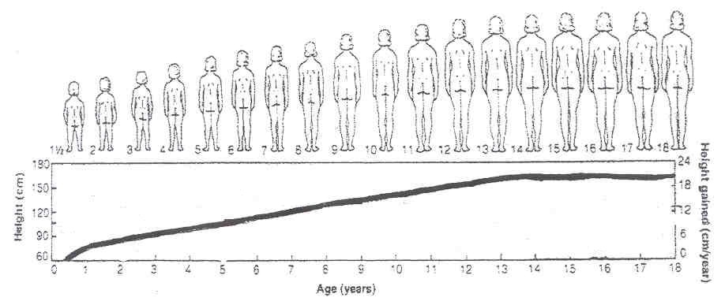

(a) 3 cm.

(b) 4 cm.

(c) 5 cm.

(d) 6 cm.

16. Amniotic fluid is important by serving as a medium

(i) for providing nutrients to the embryo.

(ii) to provide constant temperature surrounding the embryo.

(iii) to act as a shock absorber for the embryo.

(a) (i) only.

(b) (i) and (ii) only.

(c) (ii) and (iii) only.

(d) (i), (ii) and (iii).

17. The development into sexual maturity is termed

(a) adolescence.

(b) puberty.

(c) growing pains.

(d) maturity.

18. As a person ages, various parts of their body begin to change. Which of the following does NOT occur as a person ages?

(a) Lung capacity decreases.

(b) Joints become less mobile.

(c) An increase in kidney functioning leading to increased volumes of urine.

(d) A decrease in fat content of the body especially under the skin.

19. Which of the following best describes the second stage of the dying process?

(a) Body temperature falls and disintegration occurs.

(b) Muscles contract and the heart stops beating.

(c) The pupils dilate and the person urinates.

(d) The brain loses consciousness.

20. By which method are the genetic disorders Down Syndrome and Muscular Dystrophy detected?

(a) X-ray.

(b) Fetoscopy.

(c) Amniocentesis.

(d) Oogenesis.

21. The diagram below shows three stages in human development. The proportions have been made equal.

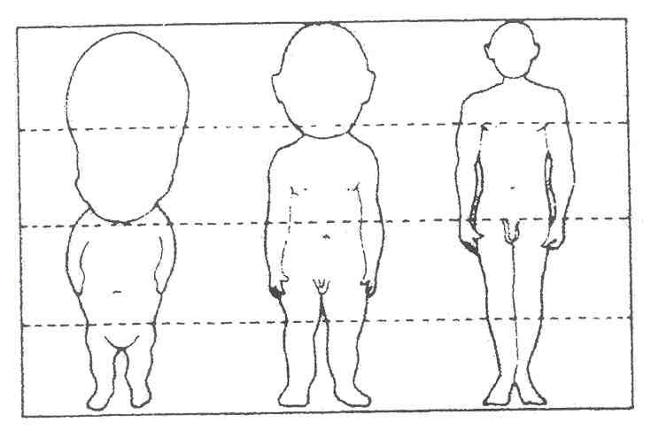

Which is the UNTRUE statement?

(a) The length of the legs increases in proportion to the body.

(b) The parts of the body develop at different rates.

(c) The head is shrinking.

(d) The arms increase in proportion to the body.

22. The following table shows deaths during infancy (first 9 months) related to types of feeding. (Statistics gathered in a third world country during the 1950’s).

|  |  |  |  |
| --- | --- | --- | --- |
| **Food** | **Number of Infants** | **Total Deaths** | **Death Rate** |
| Wholly breast fed | 9000 | 9 | 0.15 |
| Partially breast fed | 3000 | 45 | 1.5% |
| Fed artificial formula | 6000 | 270 | 4.5% |

From the table above, the death rate amongst infants fed on artificial formula is

(a) 6.0 times greater than that for partially breast fed infants.

(b) 30.0 times greater than that for wholly breast fed infants.

(c) 4.0 times greater than that for partially breast fed infants.

(d) 45.0 times greater than that for wholly breast fed infants.

23. Which of the following statements about ageing is NOT true?

(a) Decreased output and blood flow by circulation is often coupled with respiratory and kidney failure in elderly people.

(b) Ageing is generally first noticed by changes to the skin, muscle wasting, a tendency to slower reactions and slower healing rate when tissue is damaged.

(c) All body cells, including nerve and muscle cells, are capable of replication for a limited time only; cells that exceed this life span will eventually die.

(d) Greying hair, menopause, wrinkles and diminishing athletic ability are possible visible signs of the work of ageing genes.

24. Rapid, repeating uterine contractions responsible for dilation of the cervix prior to birth are better known as

(a) labour pains.

(b) peristalsis.

(c) Braxton hicks pains.

(d) all of the above.

25. Amino acids resulting from the digestive breakdown of protein are mainly absorbed in the

(a) stomach.

(b) pancreas.

(c) small intestine.

(d) large intestine.

26. Which of the following statements about the development of the fertilised ovum is INCORRECT?

(a) Fertilisation produces a zygote which contains 46 chromosomes.

(b) The fertilised ovum undergoes several mitotic divisions.

(c) The morula develops a cavity and becomes a blastocyst.

(d) The blastocyst implants in the endometrium 3 weeks after fertilisation.

27. The first sign of syphilis is usually

(a) a small copper coloured rash at the site of contact.

(b) benign growths occurring randomly in the body.

(c) white ulcers in the mouth.

(d) superficial sores at the site of contact.

28. Which of the following statements about pregnancy is INCORRECT?

(a) During late pregnancy women urinate more often because the expanding uterus exerts pressure on the bladder.

(b) The lungs of the foetus are collapsed until birth.

(c) The chorion is made from the mother’s cells.

(d) The umbilical vein carries oxygenated blood from the placenta to the foetus.

29. Digested lipids would be in the form of

(a) amino acids and glucose.

(b) glucose and glycerol.

(c) fatty acids and sucrose.

(d) fatty acids and glycerol.

30. Which is NOT a function of saliva?

(a) Lubricates the mouth.

(b) Contains antibodies that kill bacteria.

(c) Dissolves food so the taste receptors can be stimulated.

(d) Mechanical digestion.

31. Fertilisation in humans means

(a) release of an egg from the ovary.

(b) placing of the penis into the vagina.

(c) fusing of the sperm with an egg.

(d) discharging sperms at the cervix.

32. Which of the following does NOT describe a spermatozoon?

(a) A motile cell.

(b) A single cell with an ovoid-shaped head, a small middle piece and a tail.

(c) Single cell containing 46 chromosomes.

(d) Produced by the testis.

33. Cardiovascular disease is presently the most serious health problem in Australian society. The commonest cause of this disease is hypertension (high blood pressure). Which of the following suggestions is recommended to prevent hypertension?

(a) Moderately smoking, drinking and eating anything.

(b) Regular exercise and a careful dietary program.

(c) Limiting energy and salt intake, regular daily exercise, relaxation sessions and no smoking.

(d) None of the above.

34. The main function of the large intestine is

(a) absorption of bile.

(b) absorption of fatty acids and glycerol.

(c) Absorption of water.

(d) Absorption of blood.

35. Which of the following is a method that cannot lead to the spread of HIV?

(a) Having unprotected sex.

(b) Blood transfusions in countries where blood is not tested.

(c) Toilet seats in public toilets.

(d) Sharing needles and syringes.

36. Which phase in meiosis describes the formation of daughter cells with the haploid number of chromosomes in each?

(a) Anaphase II.

(b) Prophase II.

(c) Telophase II.

(d) Telophase I.

**Graph showing growth rates of human organ systems**

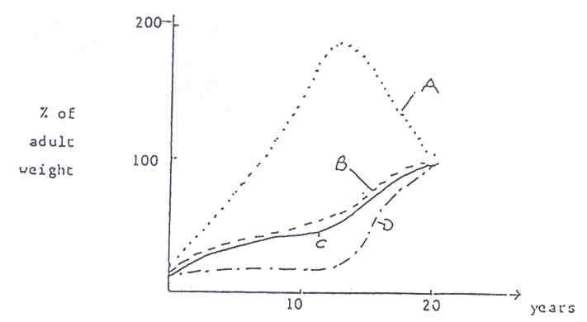

37. In the graph above, line A and D represent respectively, growth of

(a) the reproductive and nervous systems.

(b) the immune and nervous systems.

(c) cartilage in the skeleton and total body weight.

(d) the immune and reproductive systems.

38. The milk secreting regions of the human breast are called

(a) lobes.

(b) lobules.

(c) alveoli.

(d) areola.

39. Which of the following contains a body part that is not involved in digestion?

(a) Stomach, liver and gall bladder.

(b) Gall bladder, liver and colon.

(c) Stomach, duodenum and liver.

(d) Stomach, trachea and liver.

40. A guide to whether an individual is overweight is calculated using the body mass index. This is calculated in the following way.

|  |  |  |
| --- | --- | --- |
| BMI | = | weight (kg) |
| height x height (m) |

To interpret the results a standardised chart has been constructed.

|  |  |
| --- | --- |
| **Condition** | **BMI** |
| Underweight | 19.9 or less |
| Acceptable weight | 20 - 25 |
| Overweight | 25.1 - 30 |
| Obese | 30.1 - 40 |
| Extreme obesity | 40.1 or more |

If a 1.57m woman weighed 63kg, into which category would she fall?

(a) Underweight.

(b) Overweight.

(c) Acceptable weight.

(d) Obese.

**END OF MULTIPLE CHOICE SECTION**

**SCIENCE DEPARTMENT**

**YEAR 11**

**HUMAN BIOLOGY EXAMINATION**

**SEMESTER TWO 2008**

|  |  |  |  |  |
| --- | --- | --- | --- | --- |
| **Student Name:** |  |  | **Teacher:** |  |

**Time allowed for this paper**

**Reading time before commencing work: Ten minutes**

**Working time for paper: Three hours**

**section 1: Multiple Choice – 40 Questions – 40 Marks – 40%**Answer the multiple choice questions by crossing out the letter of your choice on the answer sheet provided.***Use a 2B pencil here.***

**SECTION 2: Short Answers – 8 Questions – 97 marks – 40%**Answer the questions in the spaces provided. Answers are to be in BLUE or BLACK ink.  
***GRAPHS and DRAWINGS to be in pencil and labelled in ink.***

**SECTION 3: Extended Answer – 2 Questions – 40 marks – 20%**Answer question 1 **OR** question 2  
**AND**  
Answer question 3 **OR** question 4.

## SCIENCE

**NAME:** _______________________________

**Please indicate your answer with a cross (X) within the box.**

|  |  |  |  |  |  |  |  |  |  |  |  |  |
| --- | --- | --- | --- | --- | --- | --- | --- | --- | --- | --- | --- | --- |
| **1** | A | B | C | D | E |  | **21** | A | B | C | D | E |
| **2** | A | B | C | D | E |  | **22** | A | B | C | D | E |
| **3** | A | B | C | D | E |  | **23** | A | B | C | D | E |
| **4** | A | B | C | D | E |  | **24** | A | B | C | D | E |
| **5** | A | B | C | D | E |  | **25** | A | B | C | D | E |
| **6** | A | B | C | D | E |  | **26** | A | B | C | D | E |
| **7** | A | B | C | D | E |  | **27** | A | B | C | D | E |
| **8** | A | B | C | D | E |  | **28** | A | B | C | D | E |
| **9** | A | B | C | D | E |  | **29** | A | B | C | D | E |
| **10** | A | B | C | D | E |  | **30** | A | B | C | D | E |
| **11** | A | B | C | D | E |  | **31** | A | B | C | D | E |
| **12** | A | B | C | D | E |  | **32** | A | B | C | D | E |
| **13** | A | B | C | D | E |  | **33** | A | B | C | D | E |
| **14** | A | B | C | D | E |  | **34** | A | B | C | D | E |
| **15** | A | B | C | D | E |  | **35** | A | B | C | D | E |
| **16** | A | B | C | D | E |  | **36** | A | B | C | D | E |
| **17** | A | B | C | D | E |  | **37** | A | B | C | D | E |
| **18** | A | B | C | D | E |  | **38** | A | B | C | D | E |
| **19** | A | B | C | D | E |  | **39** | A | B | C | D | E |
| **20** | A | B | C | D | E |  | **40** | A | B | C | D | E |

**SECTION 3: Extended Answers 40 MARKS**

**Fill in the answers to your essays in this booklet. Number your questions appropriately.**

**All answers are to be written in blue or black biro pen. Diagrams are to be done in pencil with labels. Spelling and grammar count towards your final mark. Good luck!**

**PART A**

ANSWER EITHER QUESTION 16 OR QUESTION 17 **– NOT BOTH**

**QUESTION 16**

You decide to buy a ham and cheese sandwich to eat for lunch from the school canteen.

1. Describe the digestive processes that occur on the sandwich.

(15 marks)

1. After the sandwich, you sit back and contemplate whether you made the best choice from your school menu. What other nutrients should you have included in your lunch to supplement your sandwich?

(5 marks)

**OR**

**QUESTION 17**

One day, while at the beach, you notice a person on the shore having difficulty with their breathing. The person’s breathing deteriorates to such an extent that you decide to go to their aid and apply expired air resuscitation.

1. Outline the steps you would take in giving expired air resuscitation.

(10 marks)

1. You are successful in your attempts to revive the person but later ponder why it was possible to revive someone with expired air. Explain how this is possible.

(2 marks)

1. Describe the adaptations of the respiratory structures which make them such an efficient gas exchange system. (8 marks)

**AND**

**PART B**

ANSWER EITHER QUESTION 18 OR QUESTION 19 **– NOT BOTH**

**QUESTION 18**

The biological effects of senescence on the human body are widespread.

(a) What is senescence? (2 marks)

(b) Discuss the changes which occur in five of the body’s systems. (15 marks)

(c) Discuss the social and psychological problems with which the aged in our society must cope. (3 marks)

**OR**

**QUESTION 19**

After fertilization occurs, changes develop in the mother’s body.

(a) Describe the changes in the uterus during pregnancy that allows pregnancy to continue.

(6 marks)

(b) Explain how the milk let-down reflex is used in taking care of a newborn baby.

(4 marks)

(c) Pregnancy finishes with the process of childbirth. Describe what happens during the

three stages of labour. Describe the role of the hormones during childbirth.

(10 marks)

|  |
| --- |
|  |
|  |
|  |
|  |
|  |
|  |
|  |
|  |
|  |
|  |
|  |
|  |
|  |
|  |
|  |
|  |
|  |
|  |
|  |
|  |
|  |
|  |
|  |
|  |
|  |

|  |
| --- |
|  |
|  |
|  |
|  |
|  |
|  |
|  |
|  |
|  |
|  |
|  |
|  |
|  |
|  |
|  |
|  |
|  |
|  |
|  |
|  |
|  |
|  |
|  |
|  |
|  |

|  |
| --- |
|  |
|  |
|  |
|  |
|  |
|  |
|  |
|  |
|  |
|  |
|  |
|  |
|  |
|  |
|  |
|  |
|  |
|  |
|  |
|  |
|  |
|  |
|  |
|  |
|  |

|  |
| --- |
|  |
|  |
|  |
|  |
|  |
|  |
|  |
|  |
|  |
|  |
|  |
|  |
|  |
|  |
|  |
|  |
|  |
|  |
|  |
|  |
|  |
|  |
|  |
|  |
|  |

|  |
| --- |
|  |
|  |
|  |
|  |
|  |
|  |
|  |
|  |
|  |
|  |
|  |
|  |
|  |
|  |
|  |
|  |
|  |
|  |
|  |
|  |
|  |
|  |
|  |
|  |
|  |

|  |
| --- |
|  |
|  |
|  |
|  |
|  |
|  |
|  |
|  |
|  |
|  |
|  |
|  |
|  |
|  |
|  |
|  |
|  |
|  |
|  |
|  |
|  |
|  |
|  |
|  |
|  |

|  |
| --- |
|  |
|  |
|  |
|  |
|  |
|  |
|  |
|  |
|  |
|  |
|  |
|  |
|  |
|  |
|  |
|  |
|  |
|  |
|  |
|  |
|  |
|  |
|  |
|  |
|  |

|  |
| --- |
|  |
|  |
|  |
|  |
|  |
|  |
|  |
|  |
|  |
|  |
|  |
|  |
|  |
|  |
|  |
|  |
|  |
|  |
|  |
|  |
|  |
|  |
|  |
|  |
|  |

|  |
| --- |
|  |
|  |
|  |
|  |
|  |
|  |
|  |
|  |
|  |
|  |
|  |
|  |
|  |
|  |
|  |
|  |
|  |
|  |
|  |
|  |
|  |
|  |
|  |
|  |
|  |

|  |
| --- |
|  |
|  |
|  |
|  |
|  |
|  |
|  |
|  |
|  |
|  |
|  |
|  |
|  |
|  |
|  |
|  |
|  |
|  |
|  |
|  |
|  |
|  |
|  |
|  |
|  |